LINUX COMMANDS

1.ls command

-to list information about the FILEs (current directory by default).

Example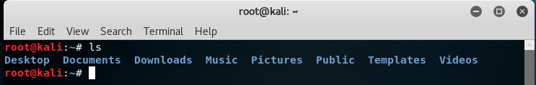

Some Command options:

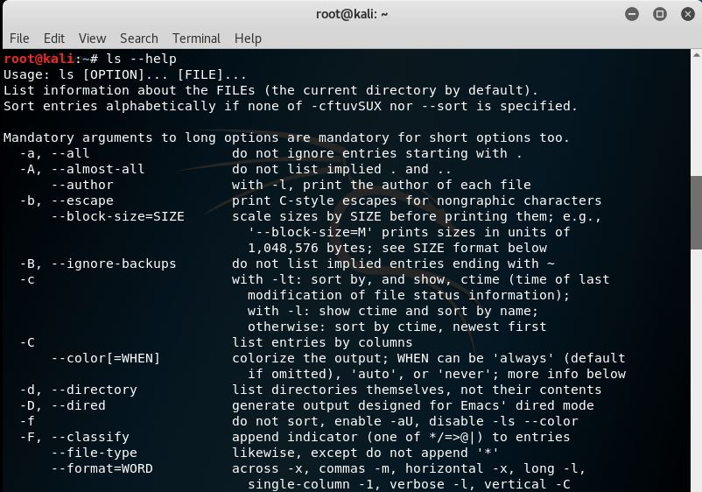

2. cd command

-change the shell work directory

-change the current directory to DIR. Default DIR is the value of the HOME shell variable

Example

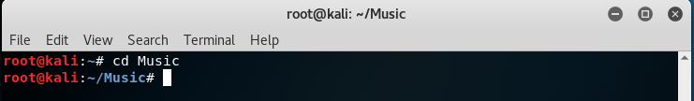

Some Command options:

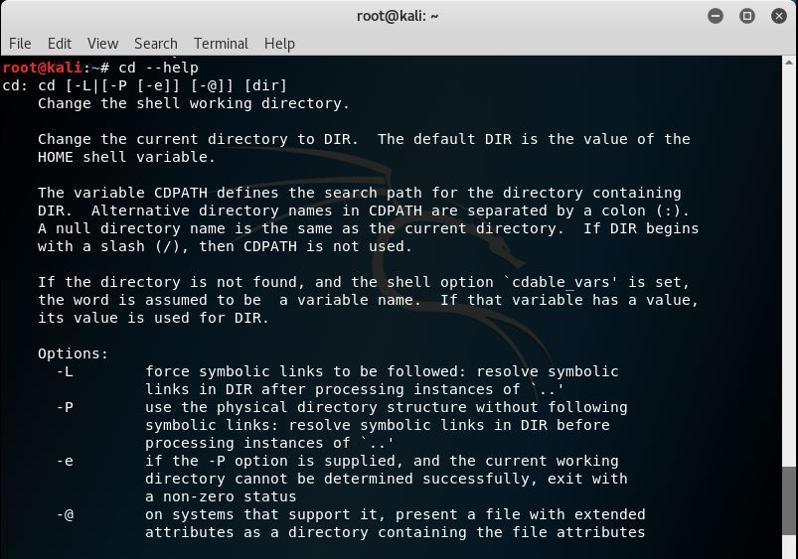

3.mv command

-use to move files and directories

Example

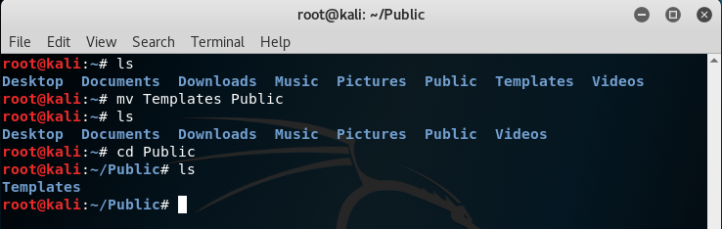

Some Command options:

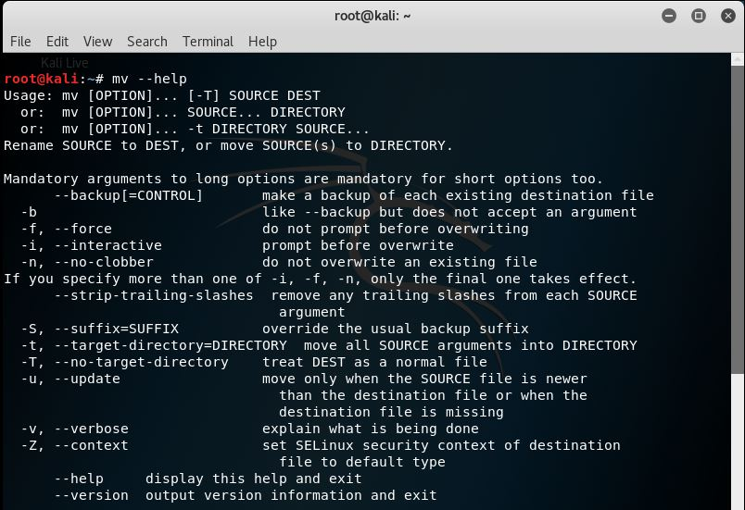

4.rm command

-use to remove files

Example

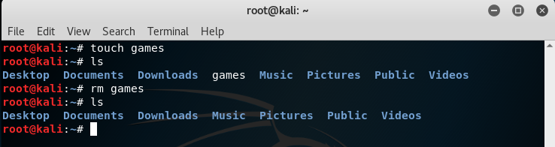

Some Commands options:

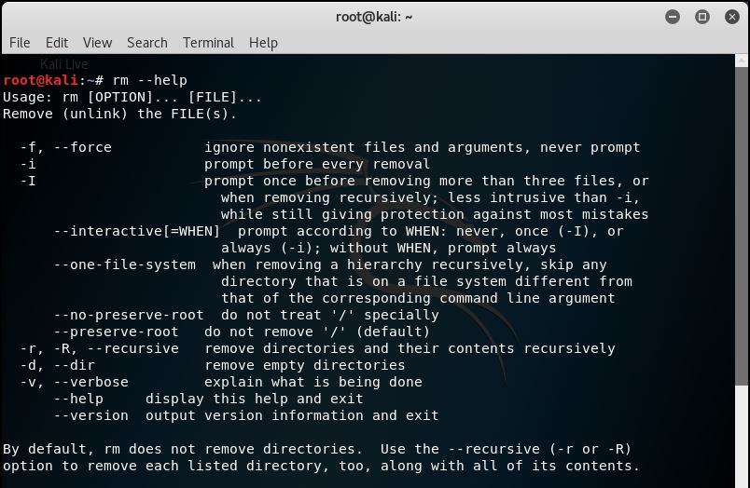

5.mkdir/rmdir commands

Mkdir – to create new directory

Rmdir – to delete directory

Example

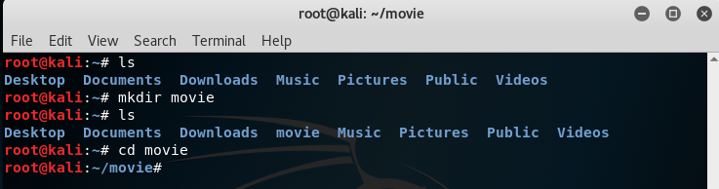

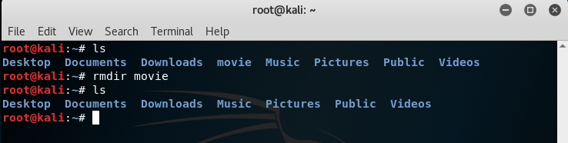

Some of commands option:

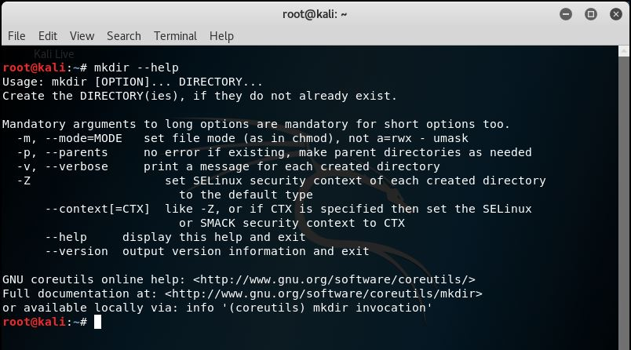

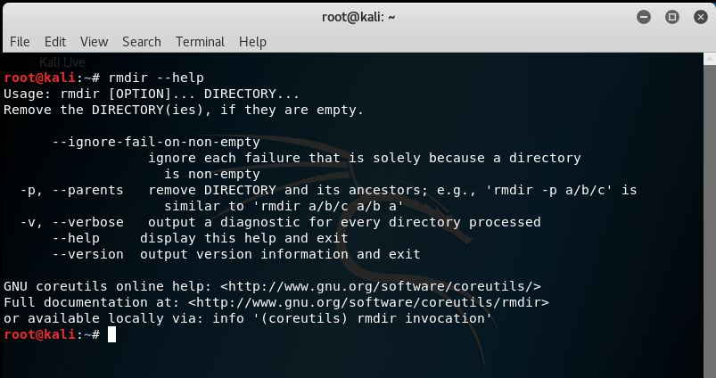

6.touch command

-to change file time stamps.

Example

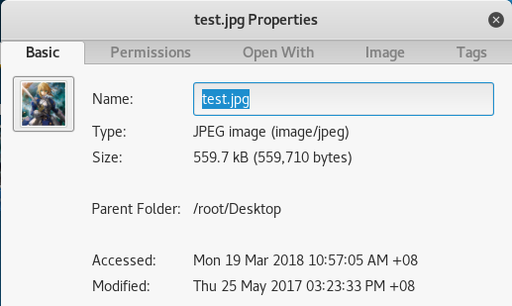



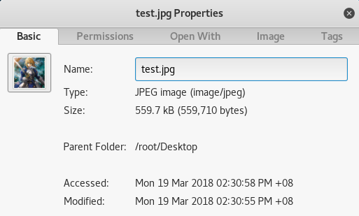

Some of commands option:

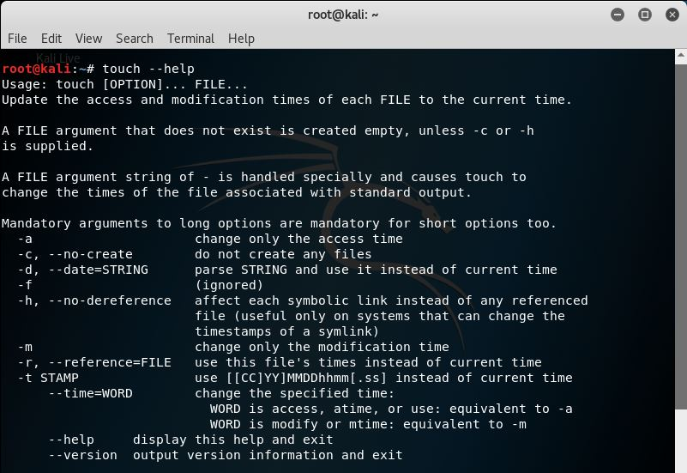

7. cat commands

-used to display the content of text files and combine several files to one file.

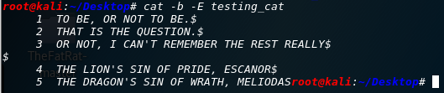Example:

Some of commands option:

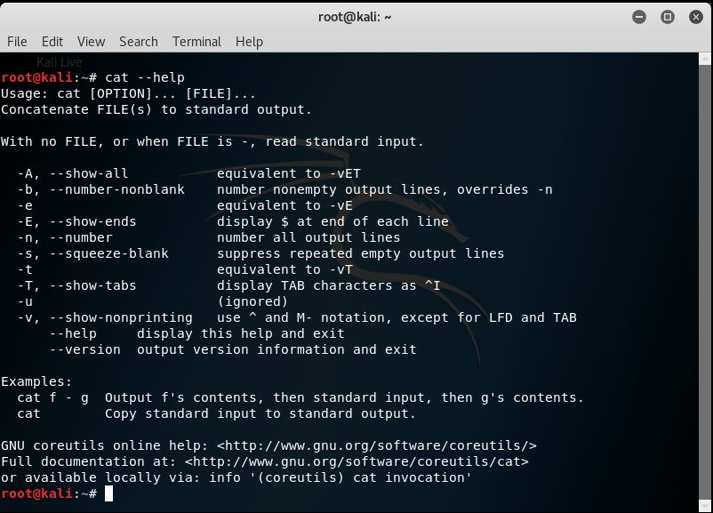

8.pwd commands

-used to print working directory, a Linux command to get the current working directory

Example:

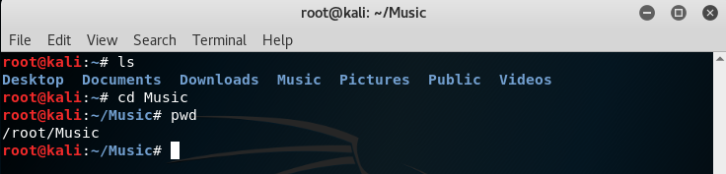

Some of command options:

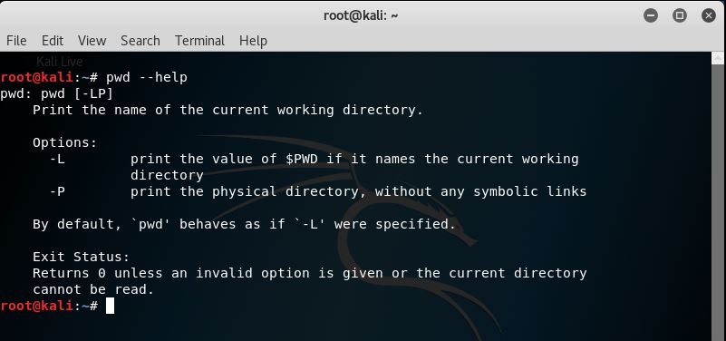

9. file command

-used to determine file type.

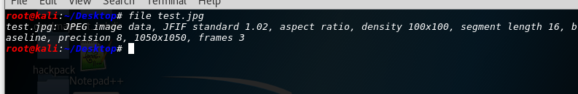Example

Some of command options:

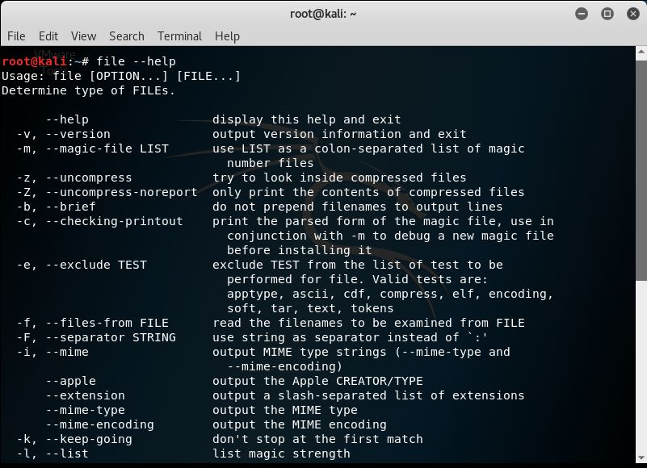

10. ln command

-to make links between files

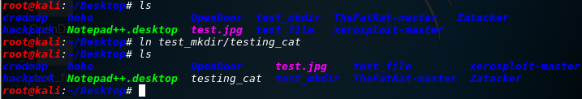Example

Some of command options:

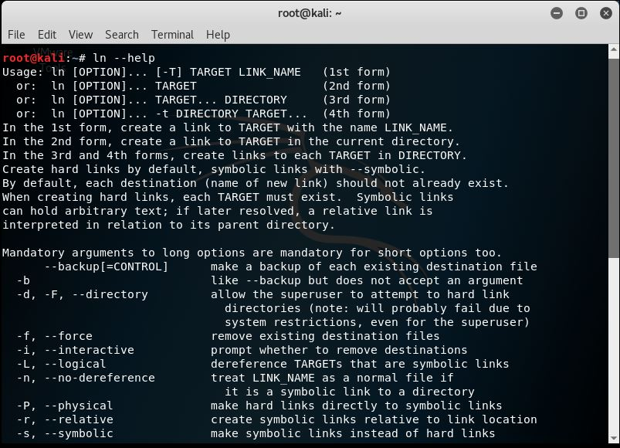

11.chmod/chown command

Chmod – to change access permissions,change mode.

Chown – to change owner, change user and/ or group ownership of each given file to new owner.

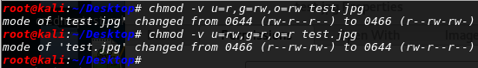Example

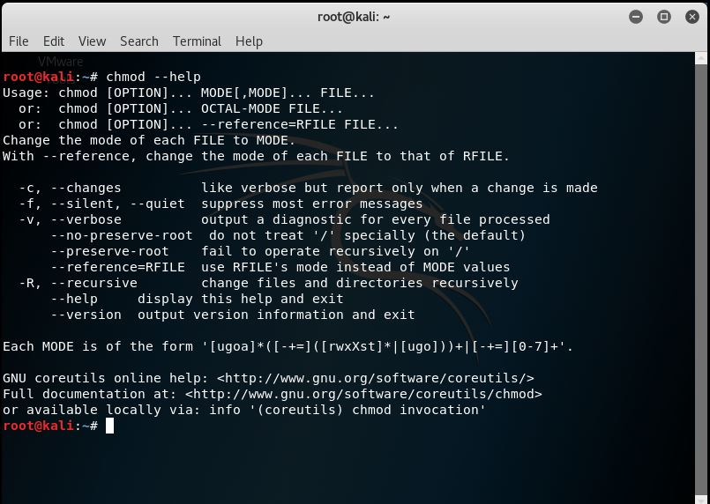Some of command options:

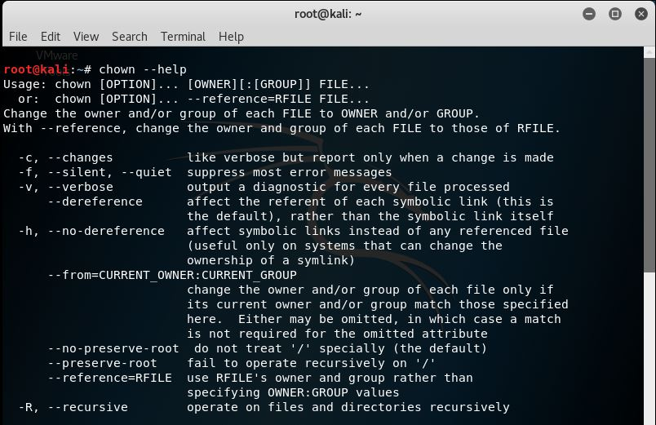

12.more/less command

More – to view a text file one page at a time, press spacebar to next page.

Less – almost same as more with some exception:

*can navigate the page up/down using less command, not possible in more command.

*can search a string in less command.

*more was fairly limited and any additional development has stopped

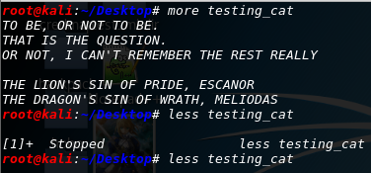Example:

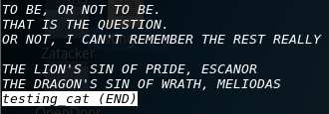

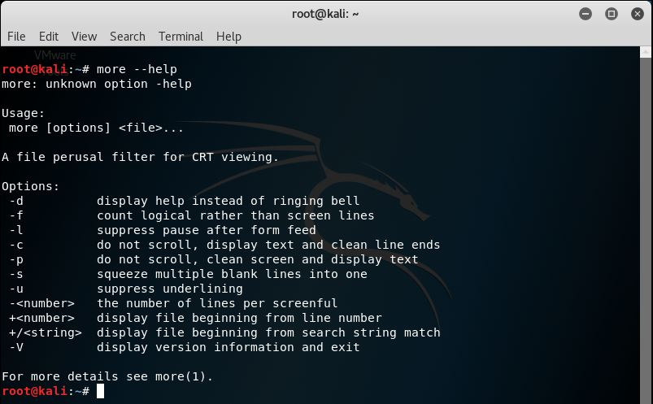Some of command options:

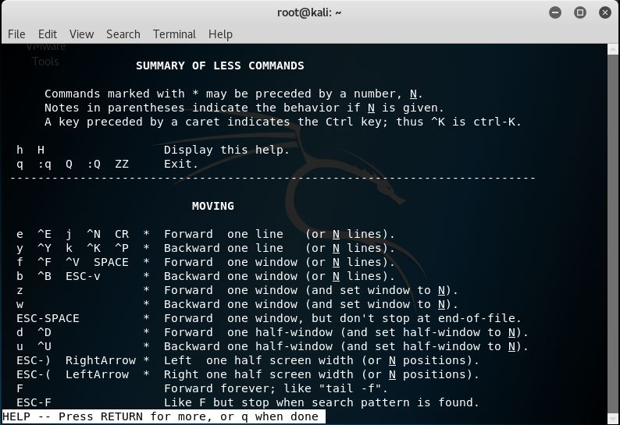

13.grep command

-use to print lines matching a pattern.

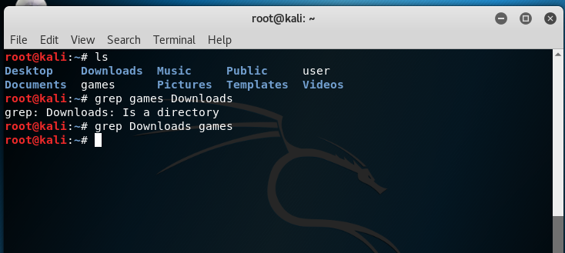Example

Some of command options:

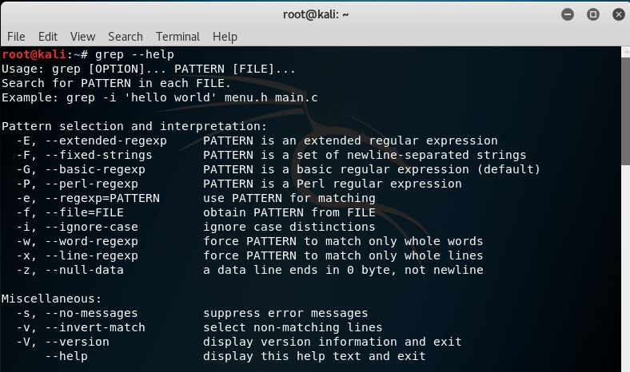

14.wc command

- will print the numbers of newlines, word and bytes in files.

Example

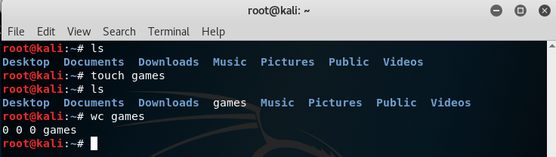

Some of command options:

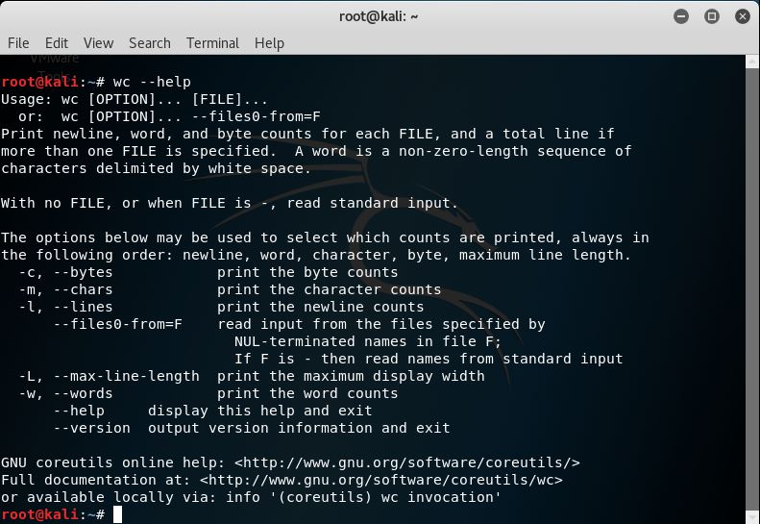

15. kill command

-used to terminate a process

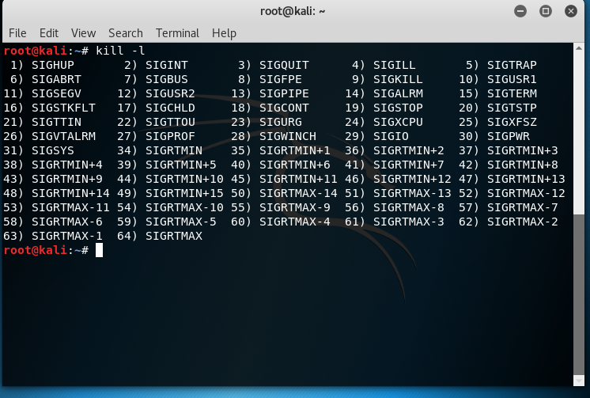Example

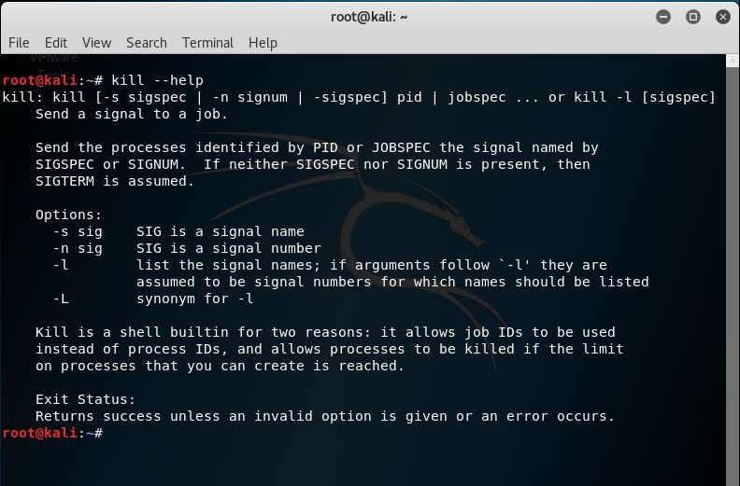Some of command options:

16.ps command

-provide information about the currently running processes.

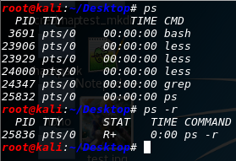

Some of command options:

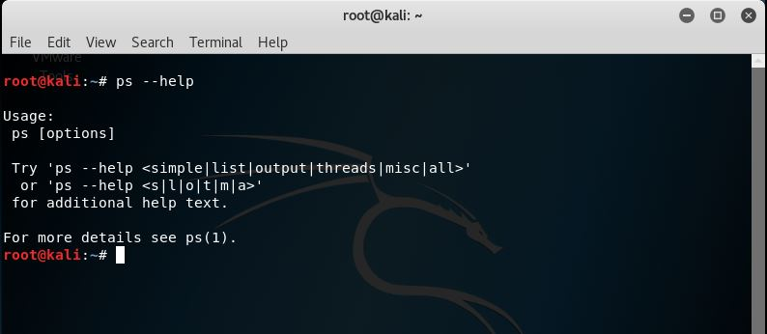

17.top command

-used to display Linux task.

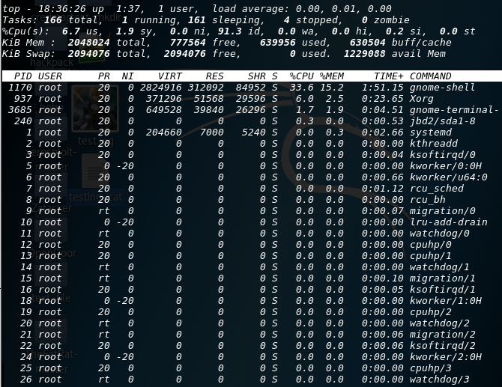Example

Some of command options:

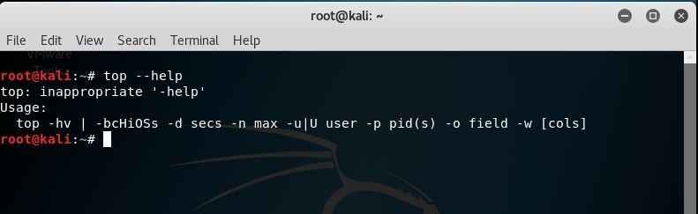

18.uname command

-use to print system information.

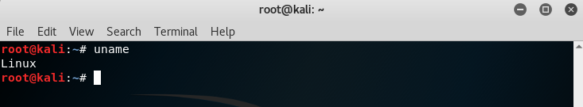Example:

Some command options:

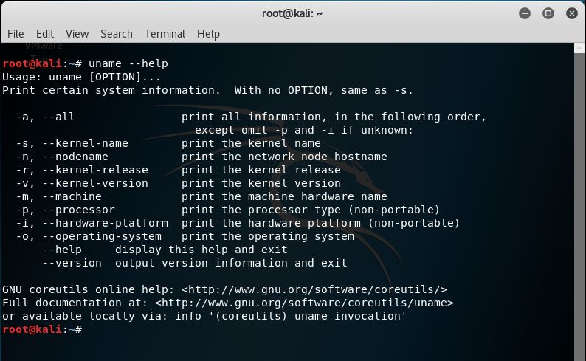

19.uptime command

-tell how long the system has been running

Example:

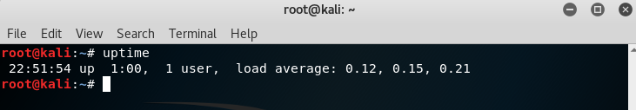

Some command options:

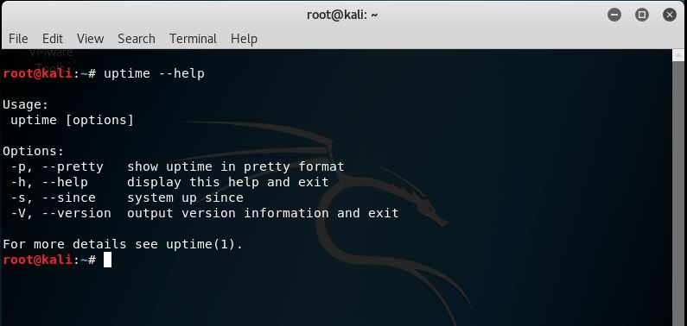

20.ping command

-send ICMP ECHO_REQUEST packets to network hosts.

Example:

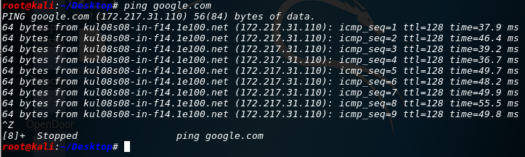

Some command options:

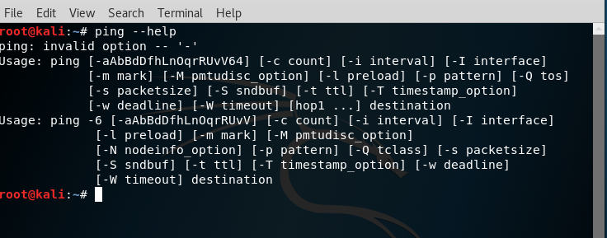

21.netstat command

-to print network connections,routing tables,interface statistics, masquerade connections and multicast memberships.

Example:

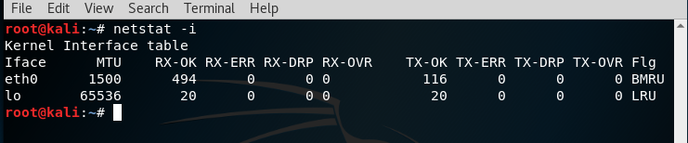

Some command options:

